REQUEST FOR QUOTATION

Date : 16 Nov 2021

From:
Norwegian Refugee Council (NRC)

Address : The Nile Tower, Fourth Floor Block No. 10 Building #20, St.63

Contact person : Tagwa Ahmed
Position : Procurement Officer
Email : sd.procurement @nrc.no
Phone : +249 11219801

Deadline for submission: 30 November 2021 @ 12:00 pm

1 - NRC is looking for the following items:

LOT 1

No | Items | Specifications | Unit | Qty | Unit Price with VAT | Total Price with VAT
1 | Illustration design & Printing | Pictorial design, illustration and printing of water proof posters on legal identity and civil documentation as per the attached guide  (8000 on national ID, 4000 on birth certificates, 2000 on death certificates, 2000 on marriage certificates)  Size A4 | pcs | 16,000
2 | Illustration design & Printing | Pictorial design, illustration and printing of water proof posters on legal identity and civil documentation as per the attached guide  (1200 on national ID cards, 1500 on birth certificates, 250 on death certificates, 250 on marriage certificates)  Size A3 | pcs | 3200
 | Total with (VAT) including delivery to Khartoum
 | Estimated Delivery Time to Khartoum – In days

LOT 2

No | Items | Specifications | Unit | Qty | Unit Price with VAT | Total Price with VAT
1 | Flyer | IEC material Information flyer on legal identity coloured printing of information flyer on legal identity | pcs | 4000
 | Total with (VAT) including delivery to Khartoum
 | Estimated Delivery Time to Khartoum – In days

You can use the above table OR print your quotation on your own letter-head documents.
In any case, be sure to include VAT (in prices or in total).
If different taxes & fees apply, please specify them all in your quotation.

Important Remarks

- Providing a printed sample is must along with the quotations.
- Logos must be of high resolution and true to color.
- No changes is allowed for the logos (must use them as they are)
- Please follow the color code for NRC in designing the sample- see attached file for color pallets
- Use the correct color code for NRC Orange – see attached file for NRC color code
- Size of the two logos must be the same (Never have one logo in a different size than NRC)
- Must adhere to NRC’s typeface in all typing.

2 - Please answer the questions:
Questions | Answers
What is the currency of the offer?
(SDG, USD, other…)
Note that NRC will favour quotes in SDG. Please read below regarding USD payments.

DO NOT PROVIDE QUOTES IN BOTH SDG AND USD CURRENCIES.

Please confirm your prices include all taxes and fees (net prices) :
(if not, please explain and detail the taxes & fees)

If your offer is in USD => payment will be made by bank transfer.
- Do you have a USD account in Sudan? if YES, then in which bank.
- Do you have a USD account abroad ? if YES, then in which bank.
(please provide bank details for each account)

Please read the note below regarding payments in USD and quote accordingly.

Do you accept payment after the delivery?
(if not, please explain your payment terms)

What is the validity period of your offer?
(in days)

Please confirm you can deliver to our address mentioned above

What is the delivery time for each LOT (LOT 1,LOT 2)

Please confirm providing printing sample for each item in each LOT / for the lot the supplier is quoting for (if the supplier did not provide a sample, he/she will not be considered for further assessment)

3 - Accepted methods for submission of quotation / offer:

We recommend you to fill up this Request for Quotation directly on your computer.
You can also print it and fill it up by hand if you have not access to a computer.
You can submit the price offer by using the table on page 1, or by using your own proforma document.

- Send by hand to the mentioned address above along with printing sample, Not providing a sample will eliminate you opportunity for further assessment.

Your quotation / offer must be signed and stamped on all pages (including the present Request for Quotation).

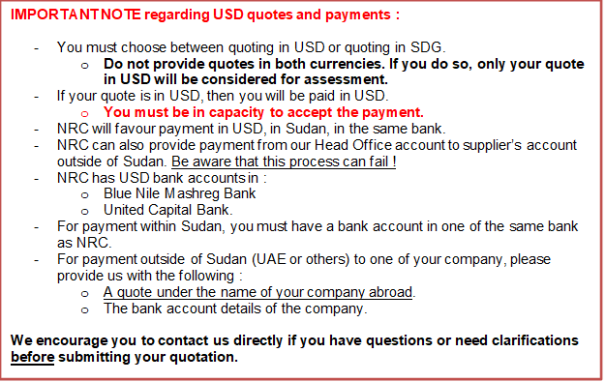

4 - Your Company details :

Name of the company

Name of the owner(s)
Date of birth of the owner(s)
(mandatory for screening)
Address of the company

Name of contact person

Position

Email

Phone

5 - Mandatory documents to attached to your quotation / offer :

Please check that you are providing all of the below mentioned documents :
Mandatory documents | Checked (Y/N)
Company registration certificate
Company tax registration certificate
NRC Request for Quotation (filled up, signed and stamped)
Additional quotation on company letter head document, if any…
Sample for each lot along with the quotation
Financial statement for the last 3 year / Proof from the bank for financial capability
Company profile
Similar previous experience

You can also attach additional documents such as photos, company profile, certifications…
6 - Payment information :

For payment by cheque, please indicate under which name NRC shall issue the cheque. You can write name in Arabic or in English.

Attention : if the name is not the company name, please provide a supporting letter to authorized NRC to issue the cheque under the name of the owner of the company or under the name of one of its employee. Contact us directly for more details.

For payment by bank transfer, please provide us with bank account information.

7 - Other information :

Payment will be made by bank transfer/cheque only.

All suppliers doing business with NRC should maintain high standards on ethical issues, respect and apply basic human and social rights, ensure non-exploitation of child labour, and give fair working conditions to their staff. NRC reserves the right to reject quotations provided by suppliers not meeting these standards.

Vendors doing business with NRC will be screened on anti-corruption due diligence before NRC confirms an order or contract.

NRC aims to purchase products and services that the minimum environmental impact. Environmental considerations form part of the NRC selection criteria, and NRC reserves the right to reject quotations provided by suppliers not meeting these standards.

NRC is obliged to ensure that its procurement decisions are clearly justified and documented and keeping within the Donors mandatory principles. In that regard, full and on-the-spot access must be granted to representatives of NRC, the Donor or any organisation or person mandated by it, to premises belonging to NRC or its contractors. The right to access shall include all documents and information necessary to assess, or audit the implementation of the contract

NRC reserves the right to accept or reject the whole or part of your quotation based on the information provided. Incomplete quotations which do not comply with our conditions will not be considered.

Shortlisted suppliers may be required to submit samples of each item. Please be sure to have all samples available at short notice, and wait for a response from NRC if you have been shortlisted.

